UI Wire Frame

1. Splash Screen
2. Home Screen

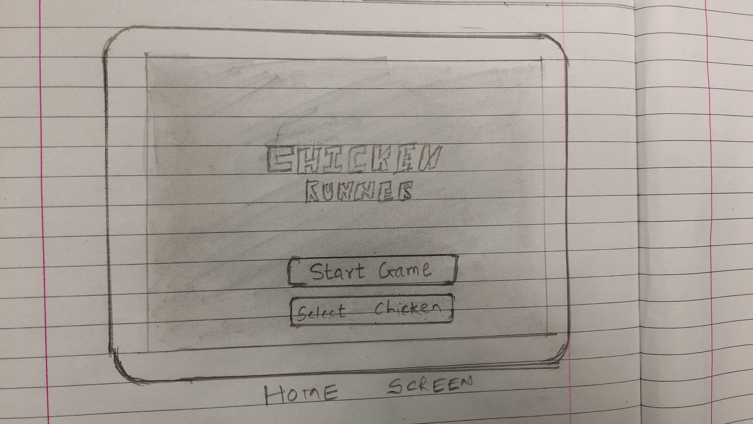

1. Character Selection Screen
2. Playing Screen
3. Game Over Screen

